**Regulation 5: Application for the Modification of a Designated Neighbourhood Area**

1. This application documents a formal request to modify the boundary of the Carlton in Lindrick Neighbourhood Area, as originally designated by Bassetlaw District Council on 26 June 2015. The application is submitted by Carlton in Lindrick Parish Council, the formally designated qualifying body in respect of the existing Carlton in Lindrick Neighbourhood Area.
2. The proposed modification, as detailed on the accompanying maps concerns a retraction of the existing Neighbourhood Area in the vicinity of Thievesdale Lane, so as to match the current boundary of Carlton in Lindrick Civil Parish.
3. When originally designated, the boundary of the Neighbourhood Area matched the boundary of the Civil Parish. The latter was subsequently modified, in response to a Community Governance Review. This change came into effect on 7 February 2023, in accordance with The Bassetlaw (Electoral Changes) Order 2023. The electoral ward boundaries in this area were also modified in the same way at this time.
4. The request to modify the Neighbourhood Area boundary has been informed by ongoing work to review the adopted Carlton in Lindrick Neighbourhood Plan. The request is based on the agreement that the reviewed Neighbourhood Plan should only have effect in the geographical area administered by the Parish Council.
5. It is understood that this request relates to the boundary of the Neighbourhood Area, not directly to the applicability of the Carlton in Lindrick Neighbourhood Plan. Subject to the modification request being agreed, the existing Neighbourhood Plan will initially continue to have effect across the entirety of the original Neighbourhood Area. The reviewed Neighbourhood Plan, currently under development, will gradually replace the original Plan in the modified Neighbourhood Area. Subject to the reviewed Neighbourhood Plan being adopted in full, it will then be possible to withdraw the original Plan from having effect in both the modified Neighbourhood Area and the remaining portion of the original Neighbourhood Area addressed by this application.
6. The requested modification is considered appropriate for the following reasons:

* It will help to provide administrative clarity, aligning the Neighbourhood Area boundary with the boundary of the Civil Parish and the electoral ward boundaries.
* The proposal does not overlap other existing designated neighbourhood areas.

1. We consider that Carlton in Lindrick Parish Council remains the appropriate body to lead neighbourhood planning in this area.

**Submitted to Bassetlaw District Council on behalf of Carlton in Lindrick Parish Council by Peter Goulding, Clerk**

**23 January 2025**

**Map 1: Proposed Neighbourhood Area Modification in Context**

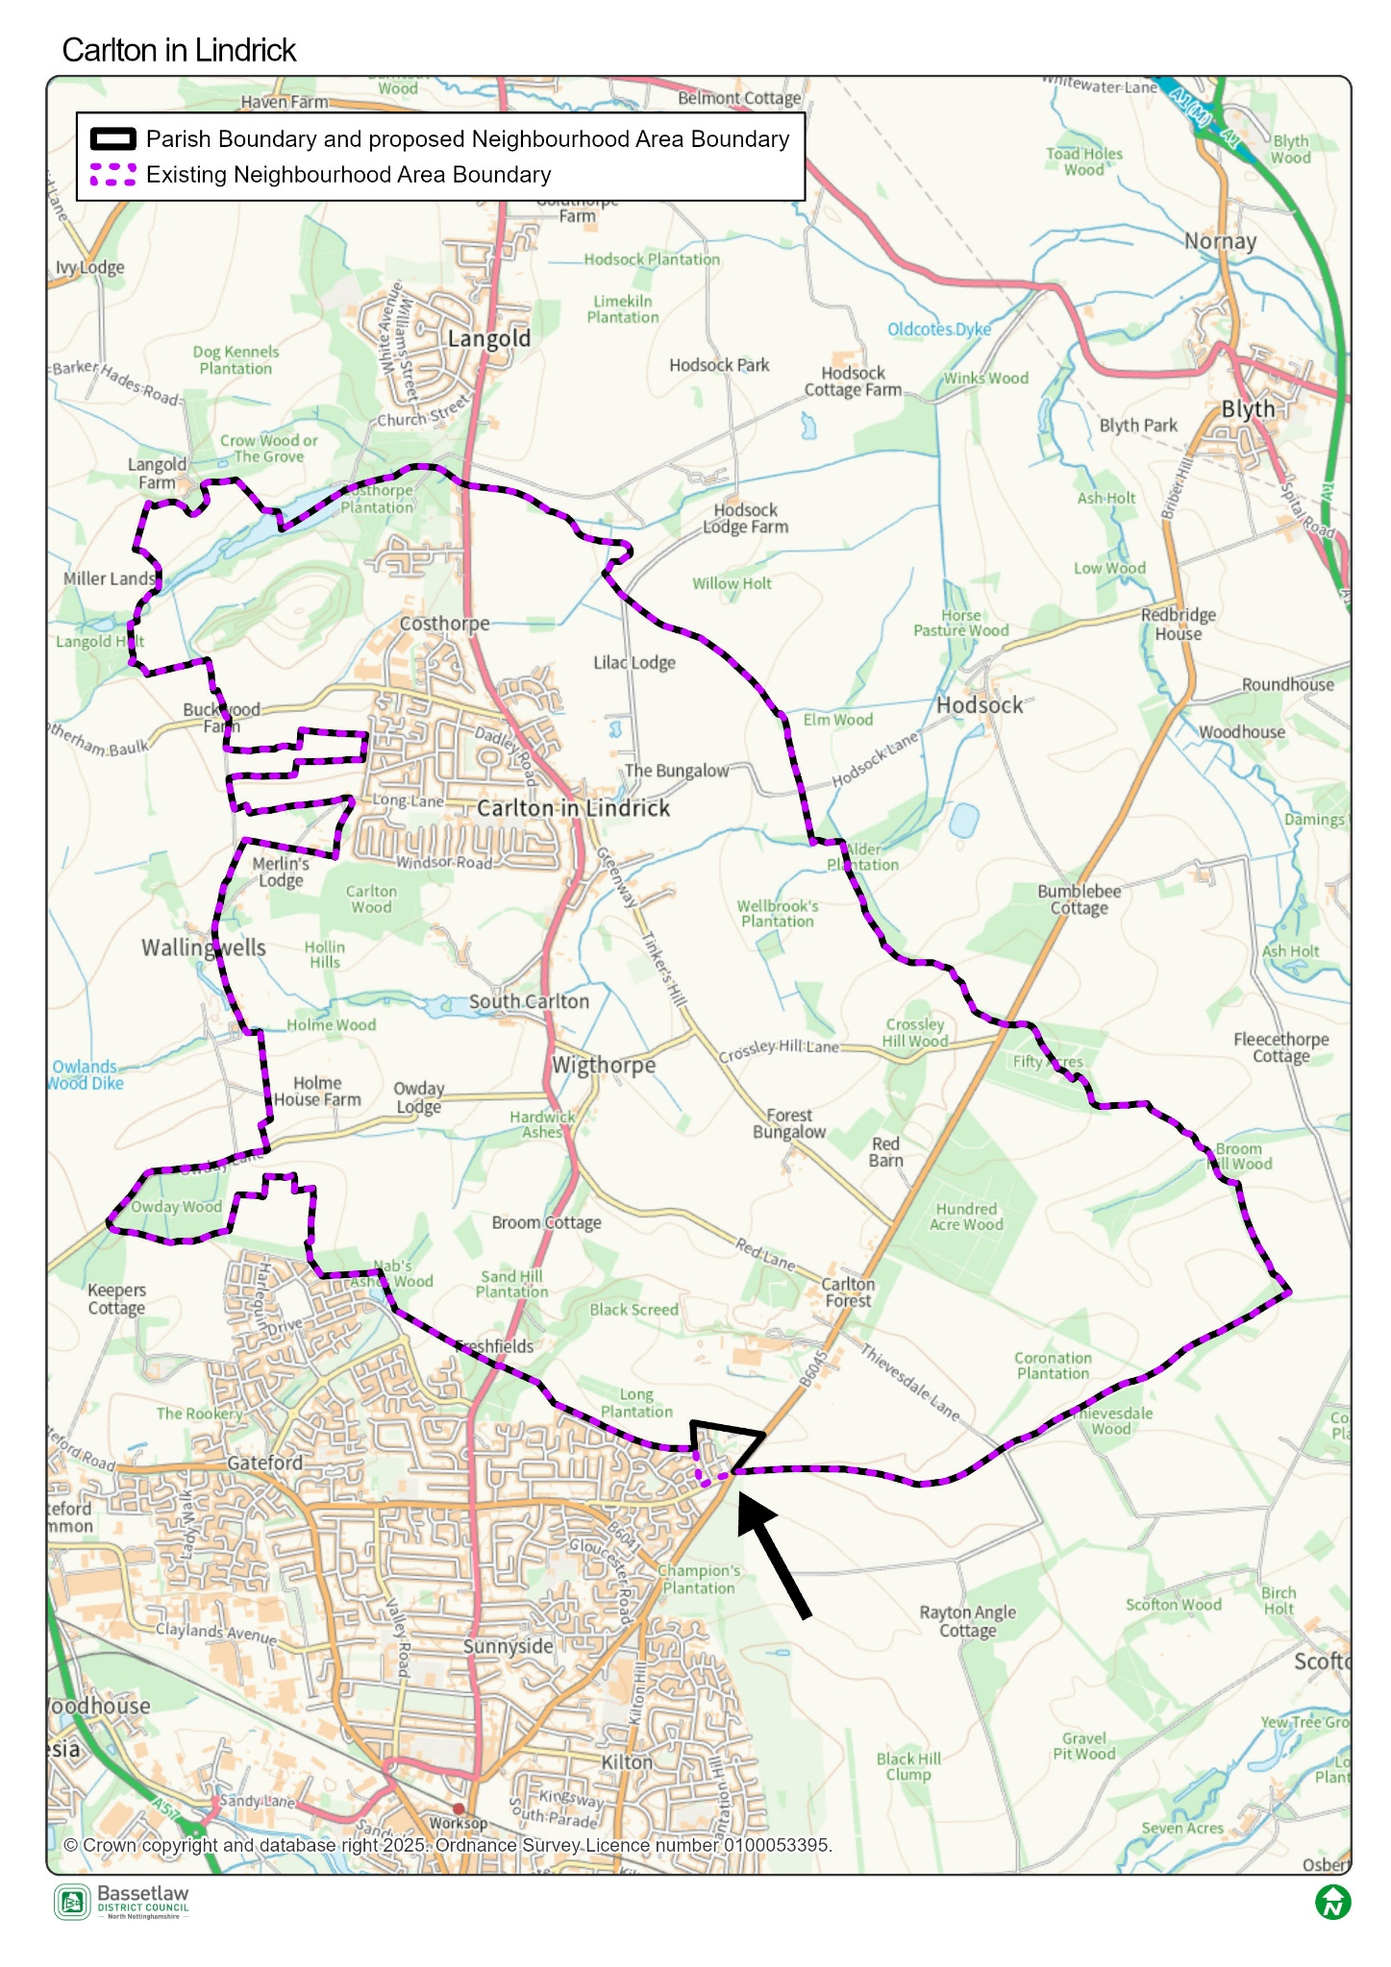

**Map 2: Proposed Neighbourhood Area Modification in Detail**

