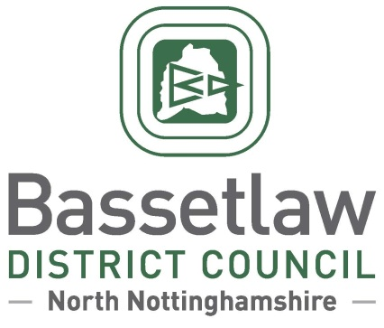

**Reviewed Sturton Ward Neighbourhood Plan:**

**Decision Statement (Adoption)**

# Summary

* + - * 1. Following a positive referendum result on the 11 November 2021, Bassetlaw District Council is publicising its decision to ‘make’ the reviewed Sturton Ward Neighbourhood Plan part of the Bassetlaw Development Plan, in accordance with Regulation 19 of the Neighbourhood Planning (General) Regulations 2012.

# Background

* + - * 1. The Sturton Ward Neighbourhood Area was designated by Bassetlaw District Council on 4 April 2014. The original Sturton Ward Neighbourhood Plan was subsequently developed, and was adopted as part of the Development Plan by the District Council following a successful referendum on 11 February 2016.
        2. Work to review the original Neighbourhood Plan commenced in 2018. The process was led by a Steering Group, consisting of representatives from across the Neighbourhood Area. North and South Wheatley Parish Council was identified as the Qualifying Body, the role previously being held by Sturton le Steeple Parish Council.
        3. The reviewed Neighbourhood Plan incorporates a range of modifications over the original Plan, including an enhanced evidence base to inform new and updated policies, addressing issues including design, green spaces, and site-specific housing allocations. At the outset, it was acknowledged that this would be a thorough review, as opposed to addressing a specific topic or policy.
        4. The reviewed Neighbourhood Plan was formally submitted to the District Council in March 2021, followed by six weeks of consultation with the public and statutory bodies. The consultation concluded in June 2021.
        5. Bassetlaw District Council subsequently appointed an independent Examiner, Mr Andrew Ashcroft, to assess whether the reviewed Neighbourhood Plan met the basic conditions required by legislation, and whether the Plan should proceed to referendum.
        6. The Examiner’s Report concluded that the Plan meets the Basic Conditions and that, subject to a number of modifications proposed in the report, the Plan should proceed to a public referendum. The Examiner’s Report, proposed modifications, and the intention to hold a referendum, were considered and approved at the Full Council meeting held on 23 September 2021.

# Decision & Reasoning

* + - * 1. A public referendum was held in the Sturton Ward Neighbourhood Area, as proposed, on Thursday 11 November 2021.
        2. Paragraph 38A (4)(a) of the Planning and Compulsory Purchase Act 2004, as amended, requires that the District Council must make the Neighbourhood Plan if more than half of those voting have voted in favour of the plan. Bassetlaw District Council is not subject to this duty if the making of the plan would breach, or would otherwise be incompatible with, any EU obligation or any of the Convention rights (within the meaning of the Human Rights Act 1998).
        3. The referendum held on 11 November 2021 met the requirements of the Localism Act 2011 and posed the question: 'Do you want Bassetlaw District Council to use the Neighbourhood Plan for Sturton Ward to help it decide planning applications in the neighbourhood area?’.
        4. The count took place on the evening of the 11 November 2021 and greater than 50% of those who voted were in favour of the plan being used to help decide planning applications in the plan area.
        5. The results of the referendum were:

Percent of votes cast in favour of a YES 86.9%

Turnout: 22.56%

* + - * 1. Bassetlaw District Council has assessed that the plan including its preparation does not breach, and would not otherwise be incompatible, with, any EU obligation or any of the Convention rights (within the meaning of the Human Rights Act 1998).
        2. In accordance with the Regulations and the Council’s procedure, the reviewed Sturton Ward Neighbourhood Plan is considered ‘made’ following the referendum held on 11 November 2021. Planning applications in the area must be considered against the reviewed Sturton Ward Neighbourhood Plan, as well as existing planning policy, such as the Bassetlaw District Core Strategy and its successors and the National Planning Policy Framework and Guidance.

**Neighbourhood Planning**

Bassetlaw District Council

November 2021