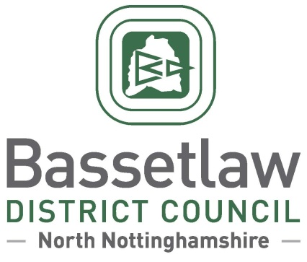

**Misson Neighbourhood Plan (Review) – Decision Statement**

# Summary

* + - * 1. In accordance with Regulation 18 of the Neighbourhood Planning (General) Regulations 2012, Bassetlaw District Council has produced this ‘Decision Statement’ in relation to the reviewed Misson Neighbourhood Plan (the ‘Plan’).
        2. Following independent examination, Bassetlaw District Council confirms that the Plan will proceed to a neighbourhood planning referendum, following enactment of the modifications specified in the Examination Report.
        3. The referendum is scheduled for Thursday 13 February 2025, based on the Misson Neighbourhood Area, as approved by Bassetlaw District Council on 20 March 2015.
        4. This Decision Statement, along with the Examination Report, can also be viewed on the [Bassetlaw District Council website](https://www.bassetlaw.gov.uk/planning-and-building/planning-services/neighbourhood-plans/all-neighbourhood-plans/misson-neighbourhood-plan/).

# Background

* + - * 1. The Misson Neighbourhood Plan currently forms part of the Development Plan for Bassetlaw, having been ‘made’ following a successful public referendum on 7 September 2017. In 2022 work commenced on a review of the Neighbourhood Plan. The review has seen modifications made to the majority of policies, including rewording of clauses to make them clearer and more specific. Policy 7, addressing the potential redevelopment of Misson Mill, has been comprehensively revised to reflect changes in the wider planning policy landscape, and Policy 10b includes the proposed designation of seven new local green spaces. Consequential changes have also been made to the supporting text throughout the Plan for consistency, clarity, and to ensure that references to other documents and legislation are up-to-date.
        2. The Pre-Submission Draft of the reviewed Misson Neighbourhood Plan was made available for consultation in accordance with Regulation 14 of the Neighbourhood Planning regulations from 2 October to 13 November 2023.
        3. The Plan was formally submitted to the District Council on 11 April 2024. Bassetlaw District Council duly consulted the public and statutory bodies on the Plan for a six week period between 15 April and 29 May 2024, in accordance with Regulation 16 of the Neighbourhood Planning regulations.
        4. An Independent Examiner was appointed to undertake the examination of the Submission version of the Neighbourhood Plan. The Examiner’s Report was sent to the District Council on 18 November 2024 and shared with Misson Parish Council and uploaded to the District Council’s website the following day.

# Decisions and Reasons

* + - * 1. The Independent Examiner has concluded that, subject to the specified modifications being enacted, the Plan meets the Basic Conditions and other relevant legal requirements. The District Council concurs with this view.
        2. The Head of Planning and Place, in consultation with the Council’s Cabinet Member for Identity and Place, has determined that all the recommended modifications set out in the Examiner’s Report will be enacted to ensure that the Plan meets the Basic Conditions. Furthermore, to meet the requirements of the Localism Act 2011, a referendum which poses the question “*Do you want Bassetlaw District Council to use the Neighbourhood Plan for Misson to help it decide planning applications in the Neighbourhood Area?*” will be held in the Misson Neighbourhood Area on Thursday 13 February 2025.

**Alastair Curran**

**Head of Planning and Place, Bassetlaw District Council**

5 December 2024

