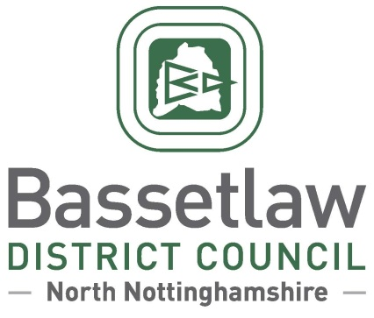
Nether Langwith Neighbourhood Plan: Decision Statement (Adoption)

Summary

        - Following a positive referendum result on the 23 May 2024, Bassetlaw District Council is publicising its decision to ‘make’ the Nether Langwith Neighbourhood Plan part of the Bassetlaw Development Plan, in accordance with Regulation 19 of the Neighbourhood Planning (General) Regulations 2012.

Background

        - The Nether Langwith Neighbourhood Area was designated by Bassetlaw District Council on 24 September 2020. Work to develop the Neighbourhood Plan followed, albeit impacted at the outset by the restrictions related to the Covid pandemic.
        - The Neighbourhood Plan was formally submitted to the District Council on 15 November 2023, followed by seven weeks of consultation with the public and statutory bodies. The consultation concluded on 5 January 2024.
        - Bassetlaw District Council subsequently appointed an independent Examiner, Mr Andrew Ashcroft, to assess whether the Neighbourhood Plan met the basic conditions required by legislation, and whether the Plan should proceed to referendum.
        - The Examiner’s Report, received on 21 February 2024, concluded that the Plan meets the Basic Conditions and that, subject to a number of specific modifications proposed in the Examination Report, the Plan should proceed to a public referendum. The Examiner’s Report, proposed modifications, and the intention to hold a referendum, were considered and approved at the Council meeting held on 7 March 2024.

Decision & Reasoning

        - A public referendum was held in the Nether Langwith Neighbourhood Area, as proposed, on Thursday 23 May 2024.
        - Paragraph 38A (4)(a) of the Planning and Compulsory Purchase Act 2004, as amended, requires that the District Council must make the Neighbourhood Plan if more than half of those voting have voted in favour of the plan. Bassetlaw District Council is not subject to this duty if the making of the plan would breach, or would otherwise be incompatible with, any EU obligation or any of the Convention rights (within the meaning of the Human Rights Act 1998).
        - The referendum held on 23 May 2024 met the requirements of the Localism Act 2011 and posed the question: 'Do you want Bassetlaw District Council to use the Neighbourhood Plan for Nether Langwith to help it decide planning applications in the Neighbourhood Area?’.
        - The count took place on the evening of the 23 May 2024 following the close of poll, and greater than 50% of those who voted were in favour of the plan being used to help decide planning applications in the plan area.
        - The results of the referendum were:
Number cast in favour of a YES: 65 (94.2%)
Number cast in favour of a NO: 4 (5.8%)
Turnout: 69 (18.75%)
        - Bassetlaw District Council has assessed that the plan including its preparation does not breach, and would not otherwise be incompatible, with, any EU obligation or any of the Convention rights (within the meaning of the Human Rights Act 1998).
        - In accordance with the Regulations and the Council’s procedure, the Nether Langwith Neighbourhood Plan is considered ‘made’ following the referendum held on 23 May 2024. Planning applications in the area must be considered against the Neighbourhood Plan, as well as existing planning policy, including the Bassetlaw Core Strategy and its successors, and the National Planning Policy Framework and Guidance.

Neighbourhood Planning
Bassetlaw District Council
24 May 2024

neighbourhoodplanning@bassetlaw.gov.uk
01909 533 495

