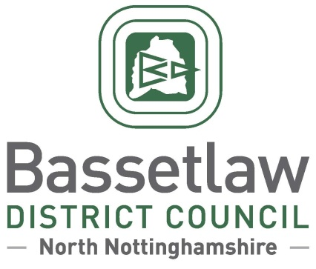

**Reviewed Misson Neighbourhood Plan: Decision Statement (Adoption)**

# Summary

* + - * 1. Following a positive referendum result on the 13 February 2025, Bassetlaw District Council is publicising its decision to adopt the reviewed Misson Neighbourhood Plan as part of the Bassetlaw Development Plan, in accordance with Regulation 19 of the Neighbourhood Planning (General) Regulations 2012.

# Background

* + - * 1. The Misson Neighbourhood Area was designated by Bassetlaw District Council on 20 March 2015. The original Misson Neighbourhood Plan was subsequently developed and was adopted as part of the Development Plan by the District Council following a successful referendum on 7 September 2017.
        2. Work to review the original Neighbourhood Plan commenced in 2022. The review has seen modifications made to the majority of policies, including rewording of clauses to make them clearer and more specific. Policy 7, addressing the potential redevelopment of Misson Mill, has been comprehensively revised to reflect changes in the wider planning policy landscape, and Policy 10b includes the proposed designation of seven new local green spaces. Consequential changes have also been made to the supporting text throughout the Plan for consistency, clarity, and to ensure that references to other documents and legislation are up-to-date.
        3. The reviewed Neighbourhood Plan was formally submitted to the District Council on 11 April 2024, followed by six weeks of consultation with the public and statutory bodies between 15 April and 29 May 2024.
        4. Bassetlaw District Council subsequently appointed an independent Examiner, Mr Andrew Ashcroft, to assess whether the reviewed Neighbourhood Plan met the basic conditions required by legislation, and whether the Plan should proceed to referendum.
        5. The Examiner’s Report, received on 18 November 2024, concluded that the Plan meets the Basic Conditions and that, subject to a number of specific modifications proposed in the report, the Plan should proceed to a public referendum. The Examiner’s Report, the proposed modifications, and the intention to hold a referendum, were considered and approved by the District Council at a meeting held on 5 December 2024.

# Decision & Reasoning

* + - * 1. A public referendum was held in the Misson Neighbourhood Area, as proposed, on Thursday 13 February 2025.
        2. Paragraph 38A (4)(a) of the Planning and Compulsory Purchase Act 2004, as amended, requires that the District Council must make the Neighbourhood Plan if more than half of those voting have voted in favour of the plan. Bassetlaw District Council is not subject to this duty if the making of the plan would breach, or would otherwise be incompatible with, any EU obligation or any of the Convention rights (within the meaning of the Human Rights Act 1998).
        3. The referendum held on 13 February 2025 met the requirements of the Localism Act 2011 and posed the question: 'Do you want Bassetlaw District Council to use the Neighbourhood Plan for Misson to help it decide planning applications in the neighbourhood area?’.
        4. The count took place on the evening of the 13 February 2025 following the close of poll, and greater than 50% of those who voted were in favour of the plan being used to help decide planning applications in the plan area.
        5. The results of the referendum were:

Number cast in favour of a **Yes**: 126 (72.4%)  
Number cast in favour of a **No**: 47 (27.01%)

Turnout: 174 (30.85%)

* + - * 1. Bassetlaw District Council has assessed that the Plan, including its preparation, does not breach, and would not otherwise be incompatible, with, any EU obligation or any of the Convention rights (within the meaning of the Human Rights Act 1998).
        2. In accordance with the Regulations and the District Council’s procedure, the reviewed Misson Neighbourhood Plan is duly adopted following the referendum held on 13 February 2025. Planning applications in the area must be considered against the Neighbourhood Plan, as well as existing planning policy, including the Bassetlaw Local Plan and the National Planning Policy Framework and Guidance.

**Neighbourhood Planning**

Bassetlaw District Council

14 February 2025

[neighbourhoodplanning@bassetlaw.gov.uk](mailto:neighbourhoodplanning@bassetlaw.gov.uk)

01909 533 495